ANDHIKA KARUNIA RIZQI – 093

WORKSHEET 1
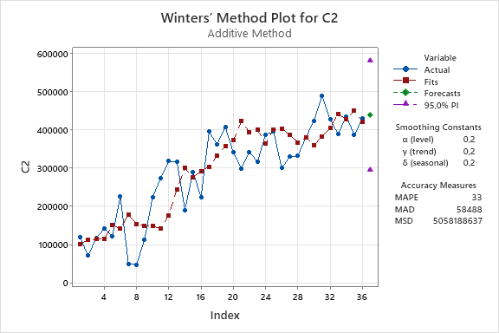
Winters’ Method for C2

Method
Model type | Additive Method
Data | C2
Length | 36
Smoothing Constants
α (level) | 0,2
γ (trend) | 0,2
δ (seasonal) | 0,2
Accuracy Measures
MAPE | 33
MAD | 58488
MSD | 5058188637
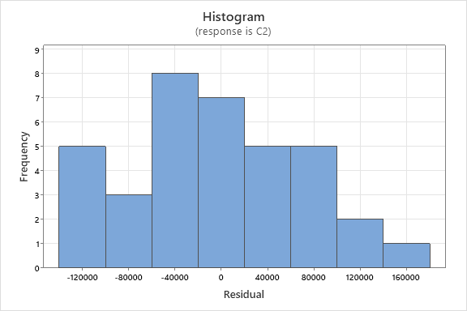
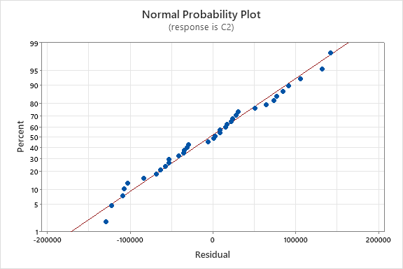
Model Summary
Time | C2 | Smooth | Predict | Error
1 | 118965 | 90347 | 101939 | 17026
2 | 71105 | 100109 | 112382 | -41277
3 | 116888 | 103718 | 114340 | 2548
4 | 142344 | 103367 | 114090 | 28254
5 | 121441 | 139592 | 151446 | -30005
6 | 225671 | 130881 | 141535 | 84136
7 | 49999 | 164966 | 178985 | -128986
8 | 47409 | 145818 | 154677 | -107268
9 | 113912 | 143753 | 148322 | -34410
10 | 224887 | 145139 | 148332 | 76555
11 | 274179 | 136147 | 142402 | 131777
12 | 318264 | 164862 | 176388 | 141876
13 | 317662 | 226950 | 244151 | 73511
14 | 191034 | 280306 | 300448 | -109414
15 | 290652 | 259905 | 275670 | 14982
16 | 224687 | 276386 | 292751 | -68064
17 | 395423 | 290386 | 304028 | 91395
18 | 362418 | 314492 | 331790 | 30628
19 | 408296 | 339159 | 357681 | 50615
20 | 341349 | 352237 | 372784 | -31435
21 | 299634 | 403259 | 422549 | -122915
22 | 341780 | 380428 | 394802 | -53022
23 | 317266 | 388638 | 400891 | -83625
24 | 388008 | 355471 | 364378 | 23630
25 | 395530 | 391229 | 401082 | -5552
26 | 299968 | 393617 | 403247 | -103279
27 | 329969 | 382136 | 387635 | -57666
28 | 332329 | 364568 | 367760 | -35431
29 | 380661 | 378130 | 379905 | 756
30 | 423745 | 358066 | 359871 | 63874
31 | 489801 | 379489 | 383849 | 105952
32 | 427258 | 397063 | 405661 | 21597
33 | 389220 | 433227 | 442689 | -53469
34 | 435834 | 420103 | 427427 | 8407
35 | 386832 | 442684 | 450344 | -63512
36 | 429996 | 416168 | 421287 | 8709
Forecasts
Period | Forecast | Lower | Upper
37 | 439732 | 296440 | 583024

WORKSHEET 1
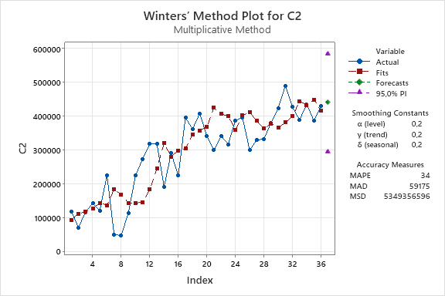
Winters’ Method for C2

Method
Model type | Multiplicative Method
Data | C2
Length | 36
Smoothing Constants
α (level) | 0,2
γ (trend) | 0,2
δ (seasonal) | 0,2
Accuracy Measures
MAPE | 34
MAD | 59175
MSD | 5349356596
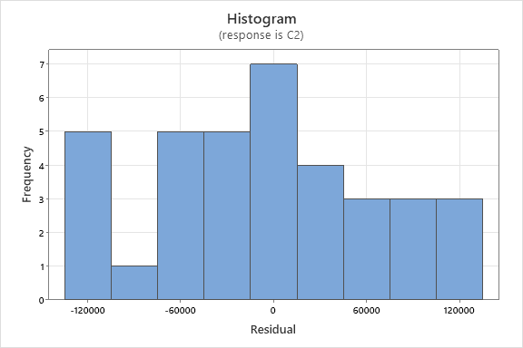
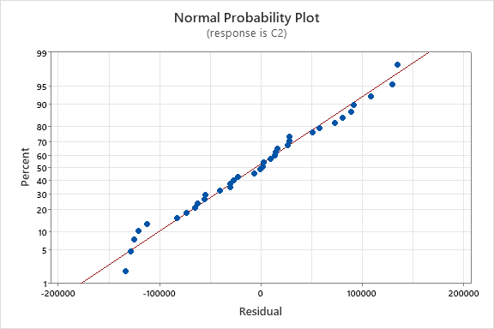
Model Summary
Time | C2 | Smooth | Predict | Error
1 | 118965 | 81665 | 93023 | 25942
2 | 71105 | 99452 | 112005 | -40900
3 | 116888 | 106617 | 117827 | -939
4 | 142344 | 116503 | 127568 | 14776
5 | 121441 | 132100 | 143896 | -22455
6 | 225671 | 126905 | 136827 | 88844
7 | 49999 | 169215 | 183964 | -133965
8 | 47409 | 158675 | 168156 | -120747
9 | 113912 | 139464 | 143968 | -30056
10 | 224887 | 140762 | 144131 | 80756
11 | 274179 | 138755 | 144468 | 129711
12 | 318264 | 172483 | 183517 | 134747
13 | 317662 | 227203 | 244933 | 72729
14 | 191034 | 296432 | 320010 | -128976
15 | 290652 | 264404 | 280957 | 9695
16 | 224687 | 281398 | 298249 | -73562
17 | 395423 | 290095 | 304325 | 91098
18 | 362418 | 327928 | 346100 | 16318
19 | 408296 | 339499 | 357793 | 50503
20 | 341349 | 348842 | 368104 | -26755
21 | 299634 | 404715 | 425011 | -125377
22 | 341780 | 391938 | 406913 | -65133
23 | 317266 | 388270 | 400464 | -83198
24 | 388008 | 351923 | 360052 | 27956
25 | 395530 | 392105 | 402022 | -6492
26 | 299968 | 402509 | 412208 | -112240
27 | 329969 | 380957 | 386050 | -56081
28 | 332329 | 360383 | 363122 | -30793
29 | 380661 | 377191 | 378784 | 1877
30 | 423745 | 364245 | 365847 | 57898
31 | 489801 | 377464 | 381382 | 108419
32 | 427258 | 391551 | 399571 | 27687
33 | 389220 | 434399 | 444186 | -54966
34 | 435834 | 426029 | 433492 | 2342
35 | 386832 | 441837 | 449531 | -62699
36 | 429996 | 411441 | 416324 | 13672
Forecasts
Period | Forecast | Lower | Upper
37 | 441115 | 296139 | 586091

